**Предиспитни пројекат**

из предмета

**Пројектовање софтверских апликација**

Датум: 27-12-2022

Студент: Сретен Прокопић, ИТ 16/20

|  |  |  |
| --- | --- | --- |
| Ставка | Интервал поена | Предложени број поена |
| Подразумевни темплејт са изменом стила/Сопствени темплејт | 5/7 |  |
| Једна класа модела/више класа модела | 6/7 |  |
| Наслеђивање: не/да | 0/1 |  |
| Custom helper:не/да | 0/1 |  |
| Форме: без валидације/са валидацијом | 6/7 |  |
| Базе података: не/да | 0/2 |  |
| Укупно: |  | |
| Поени након одбране: |  | |

# Питања:

Садржај:

1 Питања: 2

2 Код site контролера: 6

3 У Views/Shared фолдеру: 7

3.1 Код _SiteLayout фајла: 7

3.2 Код _AvailablePartial фајла: 8

4 У Views/Site фолдеру: 9

4.1 Код Index.cshtml фајла: 9

4.2 Код AvailableManga.cshtml фајла: 10

4.3 Код GetYourManga.cshtml фајла: 12

4.4 Код MangaReview.cshtml фајла: 13

4.5 Код Contact.cshtml фајла: 14

5 Модели: 17

5.1 Код Manga.cs фајла: 17

5.2 Код Sale.cs фајла: 17

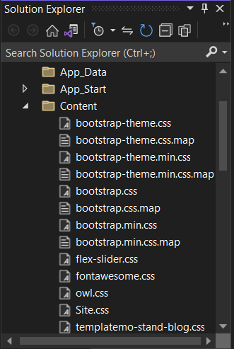

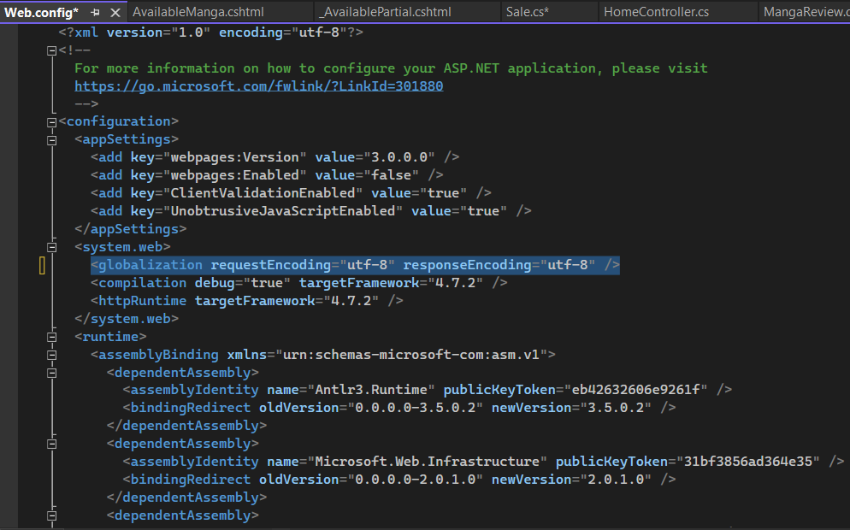

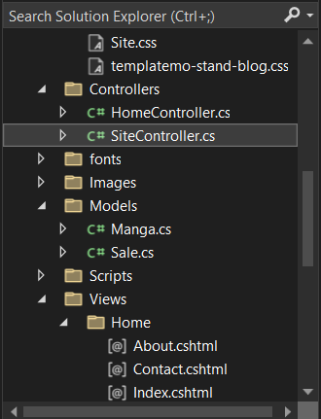

# Код site контролера:

using System;

using System.Collections.Generic;

using System.Linq;

using System.Web;

using System.Web.Mvc;

namespace MangaShop.Controllers

{

public class SiteController : Controller

{

// GET: Site

public ActionResult Index()

{

return View();

}

public ActionResult AvailableManga()

{

return View();

}

public ActionResult Contact()

{

return View();

}

[HttpGet]

public ActionResult GetYourManga()

{

return View();

}

[HttpPost]

public ActionResult GetYourManga(MangaShop.Models.Sale manga)

{

return View("MangaReview", manga);

}

}

}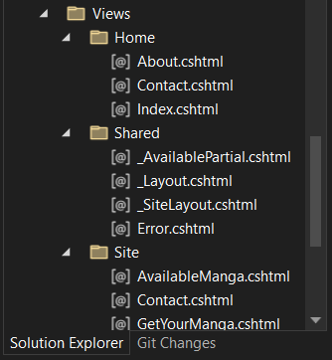

# У Views/Shared фолдеру:

## Код _SiteLayout фајла:

<!DOCTYPE html>

<html>

<head>

<meta name="viewport" content="width=device-width" />

<title>@ViewBag.Title</title>

@Styles.Render("~/Content/css")

@Scripts.Render("~/bundles/modernizr")

<link rel="stylesheet" href="~/Content/fontawesome.css">

<link rel="stylesheet" href="~/Content/templatemo-stand-blog.css">

<link rel="stylesheet" href="~/Content/owl.css">

</head>

<body style=" padding-bottom: 70px">

<div>

<div id="preloader">

<div class="jumper">

<div></div>

<div></div>

<div></div>

</div>

</div>

<header class="">

<nav class="navbar navbar-expand-lg">

<div class="container">

<a class="navbar-brand" href="index.html"><h2>Proko<em>.</em></h2></a>

<button class="navbar-toggler" type="button" data-toggle="collapse" data-target="#navbarResponsive" aria-controls="navbarResponsive" aria-expanded="false" aria-label="Toggle navigation">

<span class="navbar-toggler-icon"></span>

</button>

<div class="collapse navbar-collapse" id="navbarResponsive">

<ul class="navbar-nav ml-auto">

<li class="nav-item">

<a class="nav-link" @Html.ActionLink("Home", "Index", "Site")

<span class="sr-only">(current)</span>

</a>

</li>

<li class="nav-item">

<a class="nav-link" @Html.ActionLink("AvailableManga", "AvailableManga", "Site")</a>

</li>

<li class="nav-item">

<a class="nav-link"@Html.ActionLink("GetYourManga", "GetYourManga", "Site")</a>

</li>

<li class="nav-item">

<a class="nav-link" @Html.ActionLink("Contact", "Contact", "Site")</a>

</li>

<li class="nav-item active"@RenderSection("Telefon", false)</li>

</ul>

</div>

</div>

</nav>

</header>

@RenderBody()

</div>

@Scripts.Render("~/bundles/jquery")

@Scripts.Render("~/bundles/bootstrap")

@RenderSection("scripts", required: false)

<script src="~/Scripts/custom.js"></script>

<script src="~/Scripts/owl.js"></script>

<script src="~/Scripts/slick.js"></script>

<script src="~/Scripts/isotope.js"></script>

<script src="~/Scripts/accordions.js"></script>

<footer>

<div class="container">

<div class="row">

<div class="col-lg-12">

<ul class="social-icons">

<li><a href="#">Facebook</a></li>

<li><a href="#">Twitter</a></li>

<li><a href="#">Behance</a></li>

<li><a href="#">Linkedin</a></li>

<li><a href="#">Dribbble</a></li>

</ul>

</div>

<div class="col-lg-12">

<div class="copyright-text">

<p>

Copyright 2020 Stand Blog Co.

| Design: <a rel="nofollow" href="https://templatemo.com" target="_parent">TemplateMo</a>

<h3>@RenderSection("Dodatno", false)</h3>

</p>

</div>

</div>

</div>

</div>

</footer>

</body>

</html>

## Код _AvailablePartial фајла:

<h1>LIST OF</h1>

<h2>AVAILABLE MANGA BOOKS</h2>

# У Views/Site фолдеру:

## Код Index.cshtml фајла:

@{

ViewBag.Title = "Index";

Layout = "~/Views/Shared/_SiteLayout.cshtml";

}

<div class="main-banner header-text">

<div class="container-fluid">

<div class="owl-banner owl-carousel">

<div class="item">

<img src="~/Images/Ichigo.jpg" alt="">

<div class="item-content">

<div class="main-content">

<div class="meta-category">

<h4 style="color: #ff6a00">Bleach</h4>

</div>

<h4 style="color: #ff6a00" >Taito Kubo</h4>

</div>

</div>

</div>

<div class="item">

<img src="~/Images/Naruto.jpg" alt="">

<div class="item-content">

<div class="main-content">

<div class="meta-category">

<h4 style="color: #ff6a00">Naruto</h4>

</div>

<h4 style="color: #ff6a00">Masashi Kishimoto</h4></a>

</div>

</div>

</div>

<div class="item">

<img src="~/Images/One.jpg" alt="">

<div class="item-content">

<div class="main-content">

<div class="meta-category">

<h4 style="color: #ff6a00">One Piece</h4>

</div>

<h4 style="color: #ff6a00">Eiichiro Oda</h4>

</div>

</div>

</div>

<div class="item">

<img src="~/Images/Levi.jpg" alt="">

<div class="item-content">

<div class="main-content">

<div class="meta-category">

<h4 style="color: #ff6a00">Attack On Titan</h4>

</div>

<h4 style="color: #ff6a00">Isayama Hajime</h4>

</div>

</div>

</div>

<div class="item">

<img src="~/Images/Full.jpg" alt="">

<div class="item-content">

<div class="main-content">

<div class="meta-category">

<h4 style="color: #ff6a00">Full Metal Alchemist</h4>

</div>

<h4 style="color: #ff6a00">Arakawa Hiromu</h4></a>

</div>

</div>

</div>

<div class="item">

<img src="~/Images/Dabi.jpg" alt="">

<div class="item-content">

<div class="main-content">

<div class="meta-category">

<h4 style="color: #ff6a00">My Hero Academia</h4>

</div>

<h4 style="color: #ff6a00">Kōhei Horikoshi</h4></a>

</div>

</div>

</div>

</div>

</div>

</div>

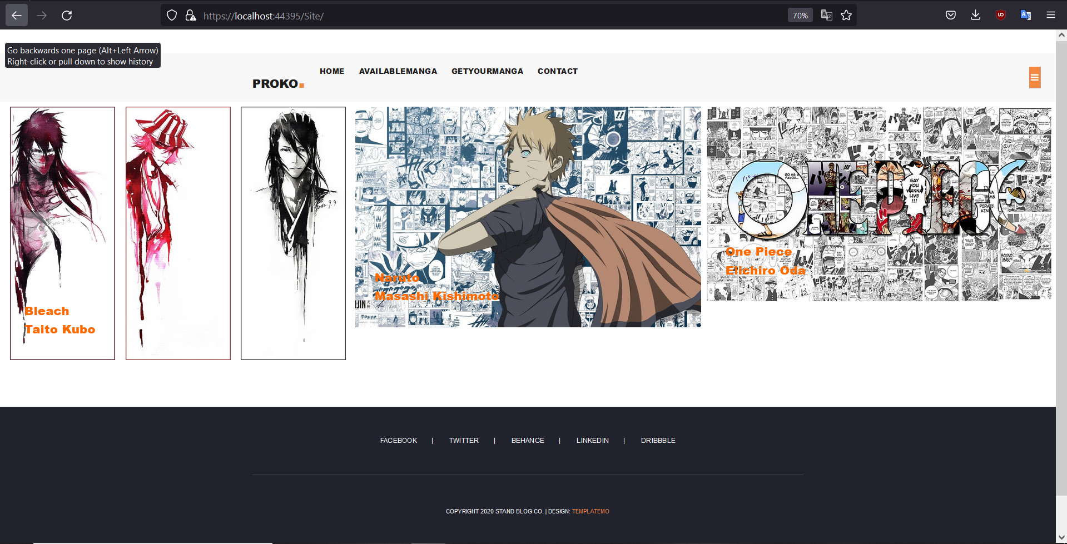

## Код AvailableManga.cshtml фајла:

@{

ViewBag.Title = "About";

Layout = "~/Views/Shared/_SiteLayout.cshtml";

}

<section class="about-us">

<div class="container">

<div class="row">

<div class="col-lg-12">

<img src="~/Images/Grimmjow.jpg" alt="">

<p>@{Html.RenderPartial("_AvailablePartial"); }</p>

</div>

<div class="row">

<div class="col-lg-6">

<h4>Bleach</h4>

<p>It follows the adventures of a teenager Ichigo Kurosaki, who inherits his parents' destiny after he obtains the powers of a Soul Reaper—a death personification similar to the Grim Reaper—from another Soul Reaper, Rukia Kuchiki.</p>

</div>

<div class="col-lg-6">

<h4>Naruto</h4>

<p>Naruto is a Japanese manga series written and illustrated by Masashi Kishimoto. It tells the story of Naruto Uzumaki, a young ninja who seeks recognition from his peers and dreams of becoming the Hokage, the leader of his village.</p>

</div>

</div>

<div class="row">

<div class="col-lg-4 col-md-6">

<h4>One piece</h4>

<p>One Piece is the story of Monkey D. Luffy, a young man who has a single dream: To find the legendary treasure known as the One Piece and become the King of the Pirates. Alongside a crew of trusted friends, Luffy sails the dangerous seas of the Grand Line to find Laugh Tale, the hidden island containing the One Piece.</p>

</div>

<div class="col-lg-4 col-md-6">

<h4>Attack On Titan</h4>

<p>It is set in a world where humanity is forced to live in cities surrounded by three enormous walls that protect them from gigantic man-eating humanoids referred to as Titans; the story follows Eren Yeager, who vows to exterminate the Titans after they bring about the destruction of his hometown and the death of his ...</p>

</div>

<div class="col-lg-4">

<h4>Full Metal Alchemist</h4>

<p>Set in the early 20th century, in a fictional universe in which alchemy is a widely practiced science, the series follows the journey of two alchemist brothers, Edward and Alphonse Elric, who are searching for the philosopher's stone to restore their bodies after a failed attempt to bring their mother back to life ...</p>

</div>

</div>

<div class="row">

<div class="col-lg-12">

<ul class="social-icons">

<li><a href="#"><i class="fa fa-facebook"></i></a></li>

<li><a href="#"><i class="fa fa-twitter"></i></a></li>

<li><a href="#"><i class="fa fa-behance"></i></a></li>

<li><a href="#"><i class="fa fa-linkedin"></i></a></li>

</ul>

</div>

</div>

</div>

</div>

</section>

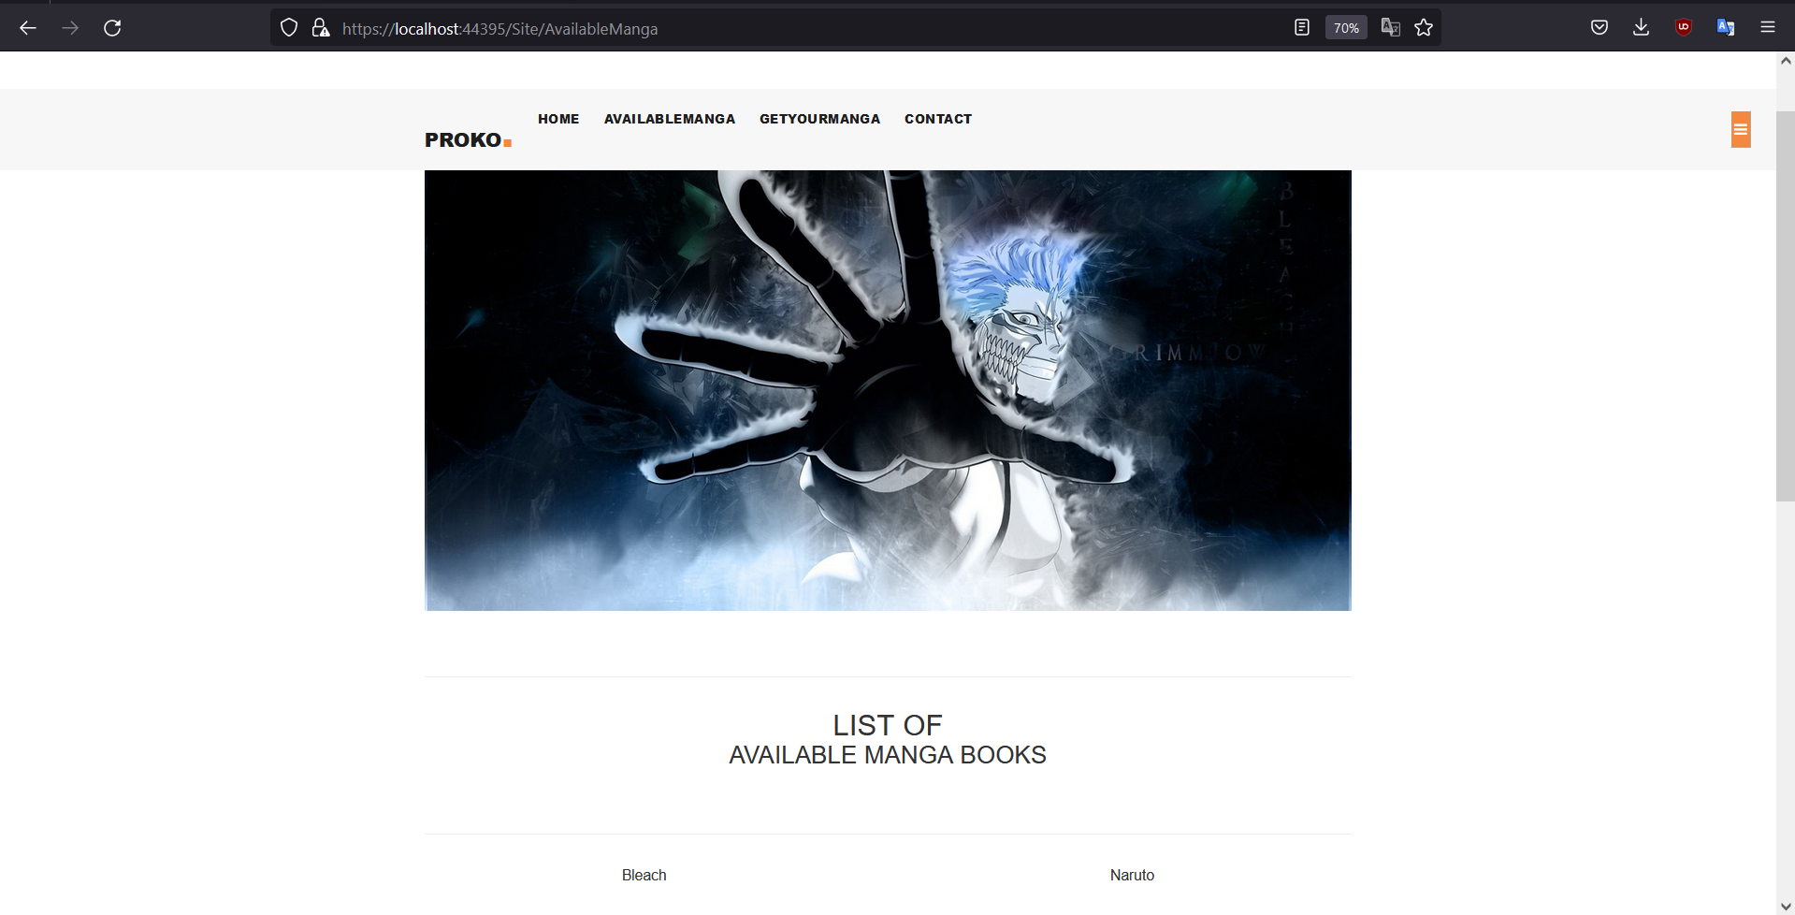

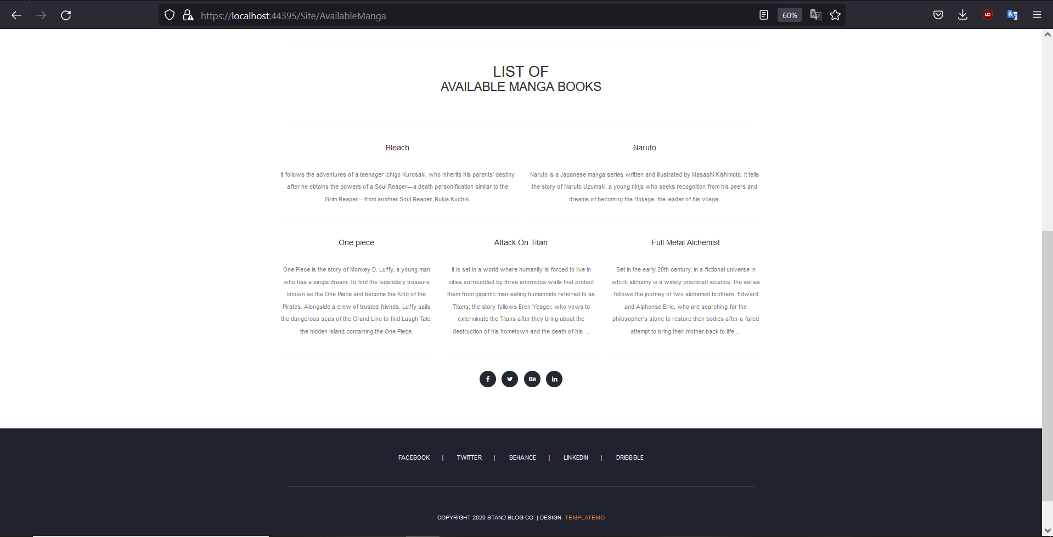

## Код GetYourManga.cshtml фајла:

@model MangaShop.Models.Sale

@{

ViewBag.Title = "GetYourManga";

Layout = "~/Views/Shared/_SiteLayout.cshtml";

}

<section class="contact-us">

<div class="container">

<div class="row">

<div class="col-lg-12">

<div class="down-contact">

<div class="row">

<div class="col-lg-8">

<div class="sidebar-item contact-form">

<div class="sidebar-heading">

<h2>Send us a message</h2>

</div>

<div class="content">

<form id="contact" action="" method="post">

<div class="row">

<div class="col-md-6 col-sm-12">

@using (Html.BeginForm("GetYourManga","Site", FormMethod.Post))

{

<div>

<label>Name:</label>

@Html.TextBoxFor(x => x.Name)

<label>Photo:</label>

@Html.TextBoxFor(x => x.Photo)

<hr />

<label>Price:</label>

@Html.TextBoxFor(x => x.Price)

<label>Publisher:</label>

@Html.DropDownListFor(x => x.Publisher, new[]

{

new SelectListItem()

{

Text = "Dark Horse Manga",

Value = "Dark Horse Manga"

},

new SelectListItem()

{

Text = "Del Rey Manga",

Value = "Del Rey Manga"

},

new SelectListItem()

{

Text = "Seven Seas Entertainment",

Value = "Seven Seas Entertainment"

}

})

</div>

<div>

<label> On Sale: </label><br>

<label> @Html.CheckBoxFor(x => x.OnSale, false) Yes </label>

</div><br><br>

}

<input type="submit" class="button" value="PURCHASE">

</div>

</div>

</form>

</div>

</div>

</div>

</div>

</div>

</div>

</div>

</div>

</section>

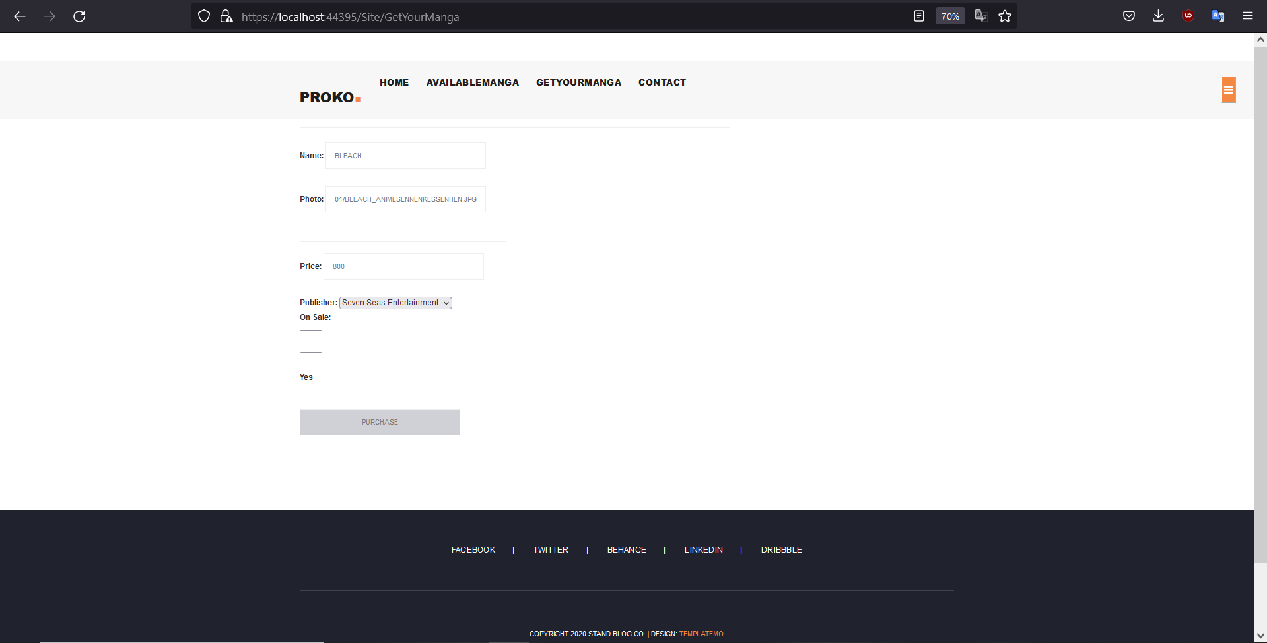

## Код MangaReview.cshtml фајла:

@model MangaShop.Models.Sale

@{ ViewBag.Title = "MangaReview";

Layout = "~/Views/Shared/_SiteLayout.cshtml";

}

<section class="about-us">

<div class="container">

<div class="row">

<div class="col-lg-12">

<img src="@Model.Photo" alt="@Model.Name" >

<h2>@Model.Name</h2>

</div>

<div class="row">

<div class="col-lg-6">

<h4>Price:</h4>

<p>@Model.Price</p>

@if (Model.OnSale == true)

{<h3><b>On Sale: </b> Yes</h3><br>}

else

{ <h3><b>On Sale: </b> No</h3><br>}

</div>

<div class="col-lg-6">

<h4>Publisher:</h4>

<p> @Model.Publisher</p>

</div>

</div>

<div class="row">

<div class="col-lg-12">

<ul class="social-icons">

<li><a href="#"><i class="fa fa-facebook"></i></a></li>

<li><a href="#"><i class="fa fa-twitter"></i></a></li>

<li><a href="#"><i class="fa fa-behance"></i></a></li>

<li><a href="#"><i class="fa fa-linkedin"></i></a></li>

</ul>

</div>

</div>

</div>

</div>

</section>

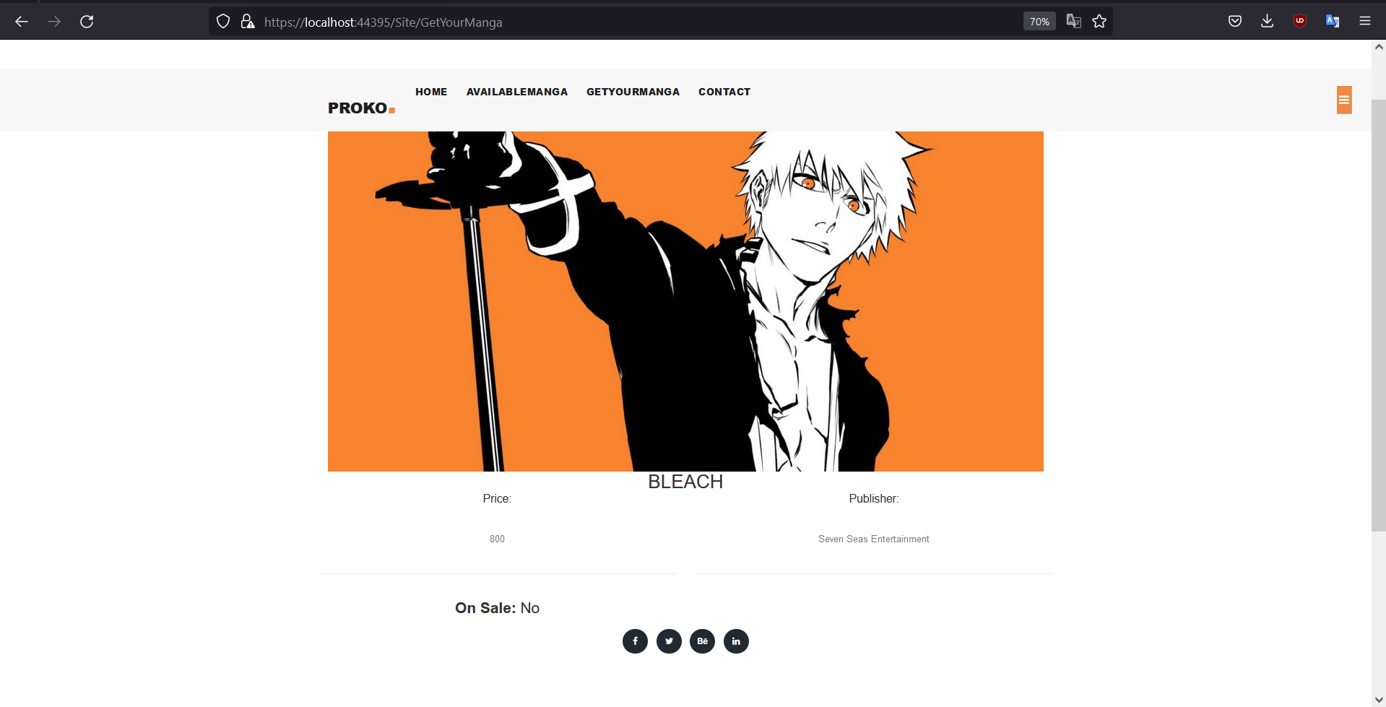

## Код Contact.cshtml фајла:

@{

ViewBag.Title = "Contact";

Layout = "~/Views/Shared/_SiteLayout.cshtml";

}

@section Telefon {<b>PHONE NUMBER:</b>

<br /><b>065/465/10/31</b>}

@section Dodatno {<b>PHONE NUMBER:</b>

<br /><b>065/465/10/31</b>}

<section class="contact-us">

<div class="container">

<div class="row">

<div class="col-lg-12">

<div class="down-contact">

<div class="row">

<div class="col-lg-8">

<div class="sidebar-item contact-form">

<div class="sidebar-heading">

<h2>Send us a message</h2>

</div>

<div class="content">

<form id="contact" action="" method="post">

<div class="row">

<div class="col-md-6 col-sm-12">

<fieldset>

<input name="name" type="text" id="name" placeholder="Your name" required="">

</fieldset>

</div>

<div class="col-md-6 col-sm-12">

<fieldset>

<input name="email" type="text" id="email" placeholder="Your email" required="">

</fieldset>

</div>

<div class="col-md-12 col-sm-12">

<fieldset>

<input name="subject" type="text" id="subject" placeholder="Subject">

</fieldset>

</div>

<div class="col-lg-12">

<fieldset>

<textarea name="message" rows="6" id="message" placeholder="Your Message" required=""></textarea>

</fieldset>

</div>

<div class="col-lg-12">

<fieldset>

<button type="submit" id="form-submit" class="main-button">Send Message</button>

</fieldset>

</div>

</div>

</form>

</div>

</div>

</div>

<div class="col-lg-4">

<div class="sidebar-item contact-information">

<div class="sidebar-heading">

<h2>contact information</h2>

</div>

<div class="content">

<ul>

<li>

<h5>065/465/10/31</h5>

<span>PHONE NUMBER</span>

</li>

<li>

<h5>info@company.com</h5>

<span>EMAIL ADDRESS</span>

</li>

<li>

<h5>

Šafarikova 20

<br>Novi Sad, 21000

</h5>

<span>STREET ADDRESS</span>

</li>

</ul>

</div>

</div>

</div>

</div>

</div>

</div>

<div class="col-lg-12">

<div id="map">

<iframe src="https://www.google.com/maps/embed?pb=!1m18!1m12!1m3!1d2808.566924778997!2d19.83958331532635!3d45.25654955529645!2m3!1f0!2f0!3f0!3m2!1i1024!2i768!4f13.1!3m3!1m2!1s0x475b104296c4440d%3A0x420091e0b24bc7bc!2z0KjQsNGE0LDRgNC40LrQvtCy0LAgMjAsINCd0L7QstC4INCh0LDQtA!5e0!3m2!1ssr!2srs!4v1671827946431!5m2!1ssr!2srs" width="100%" height="450" style="border:0;" allowfullscreen="" loading="lazy" referrerpolicy="no-referrer-when-downgrade"></iframe>

</div>

</div>

</div>

</div>

</section>

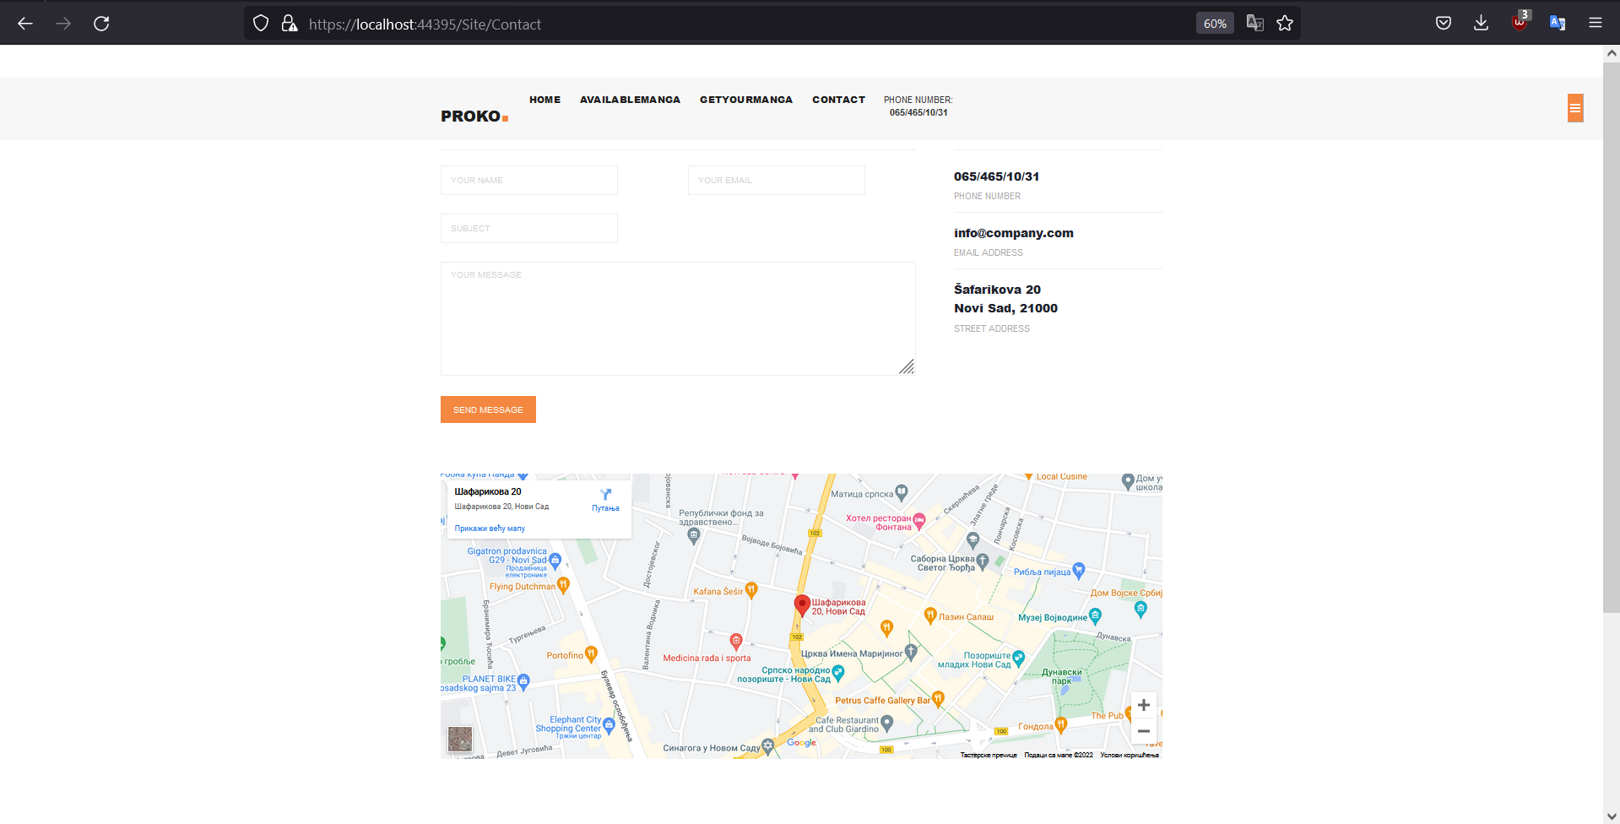 

# Модели:

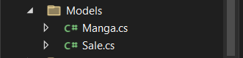

## Код Manga.cs фајла:

using System;

using System.Collections.Generic;

using System.Linq;

using System.Web;

namespace MangaShop.Models

{

public class Manga

{

public string Name { get; set; }

public string Photo { get; set; }

public double Price { get; set; }

public string Publisher { get; set; }

}

}

## Код Sale.cs фајла:

using System;

using System.Collections.Generic;

using System.Linq;

using System.Web;

namespace MangaShop.Models

{

public class Sale:Manga

{

public bool OnSale { get; set; }

}

}